|  |  |  |
| --- | --- | --- |
|  |  |  |

**UNIT - III**

**PRODUCTION FUNCTION**

***Introduction:*** The production function expresses a functional relationship between physical inputs and physical outputs of a firm at any particular time period. The output is thus a function of inputs. Mathematically production function can be written as

Q= f (A, B, C, D)

Where “Q” stands for the quantity of output and A, B, C, D are various input factors such as land, labour, capital and organization. Here output is the function of inputs. Hence output becomes the dependent variable and inputs are the independent variables.

The above function does not state by how much the output of “Q” changes as a consequence of change of variable inputs. In order to express the quantitative relationship between inputs and output, Production function has been expressed in a precise mathematical equation i.e.

Y= a+b(x)

Which shows that there is a constant relationship between applications of input (the only factor input ‘X’ in this case) and the amount of output (y) produced.

***Importance:***

1. When inputs are specified in physical units, production function helps to estimate the level of production.
2. It becomes is equates when different combinations of inputs yield the same level of output.
3. It indicates the manner in which the firm can substitute on input for another without altering the total output.
4. When price is taken into consideration, the production function helps to select the least combination of inputs for the desired output.
5. It considers two types’ input-output relationships namely ‘law of variable proportions’ and ‘law of returns to scale’. Law of variable propositions explains the pattern of output in the short-run as the units of variable inputs are increased to increase the output. On the other hand law of returns to scale explains the pattern of output in the long run as all the units of inputs are increased.
6. The production function explains the maximum quantity of output, which can be produced, from any chosen quantities of various inputs or the minimum quantities of various inputs that are required to produce a given quantity of output.

Production function can be fitted the particular firm or industry or for the economy as whole. Production function will change with an improvement in technology.

**LAW OF PRODUCTION:**

Production analysis in economics theory considers two types of input-output relationships.

1. When quantities of certain inputs, are fixed and others are variable and
2. When all inputs are variable.

These two types of relationships have been explained in the form of laws.

1. Law of variable proportions
2. Law of returns to scale

**I. Law of variable proportions:**

The law of variable proportions which is a new name given to old classical concept of “Law of diminishing returns has played a vital role in the modern economics theory. Assume that a firms production function consists of fixed quantities of all inputs (land, equipment, etc.) except labour which is a variable input when the firm expands output by employing more and more labour it alters the proportion between fixed and the variable inputs. The law can be stated as follows:

“When total output or production of a commodity is increased by adding units of a variable input while the quantities of other inputs are held constant, the increase in total production becomes after some point, smaller and smaller”.

“If equal increments of one input are added, the inputs of other production services being held constant, beyond a certain point the resulting increments of product will decrease i.e. the marginal product will diminish”. (**G. Stigler**)

“As the proportion of one factor in a combination of factors is increased, after a point, first the marginal and then the average product of that factor will diminish”. (**F. Benham**)

The law of variable proportions refers to the behaviour of output as the quantity of one Factor is increased Keeping the quantity of other factors fixed and further it states that the marginal product and average product will eventually do cline. This law states three types of productivity an input factor – Total, average and marginal physical productivity.

***Assumptions of the Law***: The law is based upon the following assumptions:

1. The state of technology remains constant. If there is any improvement in technology, the average and marginal out put will not decrease but increase.
2. Only one factor of input is made variable and other factors are kept constant. This law does not apply to those cases where the factors must be used in rigidly fixed proportions.
3. All units of the variable factors are homogenous.

**Three stages of law:**

The behaviors of the Output when the varying quantity of one factor is combines with a fixed quantity of the other can be divided in to three district stages. The three stages can be better understood by following the table.

|  |  |  |  |  |  |
| --- | --- | --- | --- | --- | --- |
| Fixed factor | Variable factor (Labour) | Total product | Average Product | Marginal Product | |
| 1 | 1 | 100 | 100 | - | Stage I |
| 1 | 2 | 220 | 120 | 120 |
| 1 | 3 | 270 | 90 | 50 |
| 1 | 4 | 300 | 75 | 30 | Stage II |
| 1 | 5 | 320 | 64 | 20 |
| 1 | 6 | 330 | 55 | 10 |
| 1 | 7 | 330 | 47 | 0 | Stage III |
| 1 | 8 | 320 | 40 | -10 |

Above table reveals that both average product and marginal product increase in the beginning and then decline of the two marginal products drops of faster than average product. Total product is maximum when the farmer employs 6th worker, nothing is produced by the 7th worker and its marginal productivity is zero, whereas marginal product of 8th worker is ‘-10’, by just creating credits 8th worker not only fails to make a positive contribution but leads to a fall in the total output.

Production function with one variable input and the remaining fixed inputs is illustrated as below

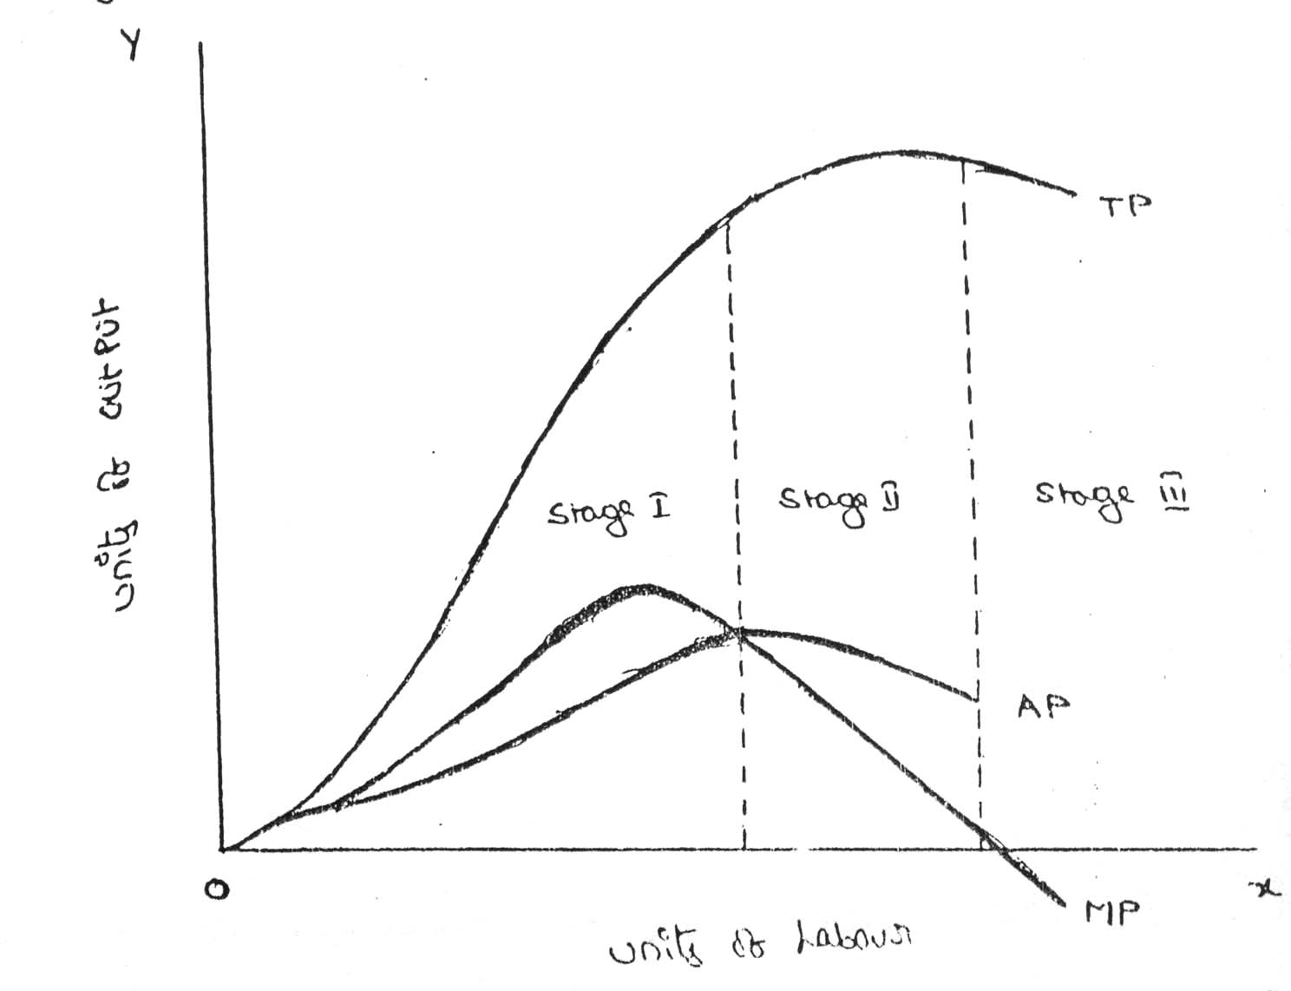

From the above graph the law of variable proportions operates in three stages. In the first stage, total product increases at an increasing rate. The marginal product in this stage increases at an increasing rate resulting in a greater increase in total product. The average product also increases. This stage continues up to the point where average product is equal to marginal product. The law of increasing returns is in operation at this stage. The law of diminishing returns starts operating from the second stage awards. At the second stage total product increases only at a diminishing rate. The average product also declines. The second stage comes to an end where total product becomes maximum and marginal product becomes zero. The marginal product becomes negative in the third stage. So the total product also declines. The average product continues to decline.

We can sum up the above relationship thus when ‘A.P.’ is rising, “M. P.’ rises more than “ A. P; When ‘A. P.” is maximum and constant, ‘M. P.’ becomes equal to ‘A. P.’ when ‘A. P.’ starts falling, ‘M. P.’ falls faster than ‘ A. P.’.

Thus, the total product, marginal product and average product pass through three phases, viz., increasing diminishing and negative returns stage. The law of variable proportion is nothing but the combination of the law of increasing and demising returns.

**II. Law of Returns of Scale:**

The law of returns to scale explains the behavior of the total output in response to change in the scale of the firm, i.e., in response to a simultaneous to changes in the scale of the firm, i.e., in response to a simultaneous and proportional increase in all the inputs. More precisely, the Law of returns to scale explains how a simultaneous and proportionate increase in all the inputs affects the total output at its various levels.

The concept of variable proportions is a short-run phenomenon as in these period fixed factors can not be changed and all factors cannot be changed. On the other hand in the long-term all factors can be changed as made variable. When we study the changes in output when all factors or inputs are changed, we study returns to scale. An increase in the scale means that all inputs or factors are increased in the same proportion. In variable proportions, the cooperating factors may be increased or decreased and one faster (Ex. Land in agriculture (or) machinery in industry) remains constant so that the changes in proportion among the factors result in certain changes in output. In returns to scale all the necessary factors or production are increased or decreased to the same extent so that whatever the scale of production, the proportion among the factors remains the same.

When a firm expands, its scale increases all its inputs proportionally, then technically there are three possibilities. (i) The total output may increase proportionately (ii) The total output may increase more than proportionately and (iii) The total output may increase less than proportionately. If increase in the total output is proportional to the increase in input, it means constant returns to scale. If increase in the output is greater than the proportional increase in the inputs, it means increasing return to scale. If increase in the output is less than proportional increase in the inputs, it means diminishing returns to scale.

Let us now explain the laws of returns to scale with the help of isoquants for a two-input and single output production system.

**ECONOMIES OF SCALE**

Production may be carried on a small scale or o a large scale by a firm. When a firm expands its size of production by increasing all the factors, it secures certain advantages known as economies of production. Marshall has classified these economies of large-scale production into internal economies and external economies.

Internal economies are those, which are opened to a single factory or a single firm independently of the action of other firms. They result from an increase in the scale of output of a firm and cannot be achieved unless output increases. Hence internal economies depend solely upon the size of the firm and are different for different firms.

External economies are those benefits, which are shared in by a number of firms or industries when the scale of production in an industry or groups of industries increases. Hence external economies benefit all firms within the industry as the size of the industry expands.

**Causes of internal economies:**

Internal economies are generally caused by two factors

1. Indivisibilities 2. Specialization.

1. **Indivisibilities**

Many fixed factors of production are indivisible in the sense that they must be used in a fixed minimum size. For instance, if a worker works half the time, he may be paid half the salary. But he cannot be chopped into half and asked to produce half the current output. Thus as output increases the indivisible factors which were being used below capacity can be utilized to their full capacity thereby reducing costs. Such indivisibilities arise in the case of labour, machines, marketing, finance and research.

1. **Specialization.**

Division of labour, which leads to specialization, is another cause of internal economies. Specialization refers to the limitation of activities within a particular field of production. Specialization may be in labour, capital, machinery and place. For example, the production process may be split into four departments relation to manufacturing, assembling, packing and marketing under the charge of separate managers who may work under the overall charge of the general manger and coordinate the activities of the for departments. Thus specialization will lead to greater productive efficiency and to reduction in costs.

**Internal Economies:**

Internal economies may be of the following types.

***A). Technical Economies.***

Technical economies arise to a firm from the use of better machines and superior techniques of production. As a result, production increases and per unit cost of production falls. A large firm, which employs costly and superior plant and equipment, enjoys a technical superiority over a small firm. Another technical economy lies in the mechanical advantage of using large machines. The cost of operating large machines is less than that of operating mall machine. More over a larger firm is able to reduce it’s per unit cost of production by linking the various processes of production. Technical economies may also be associated when the large firm is able to utilize all its waste materials for the development of by-products industry. Scope for specialization is also available in a large firm. This increases the productive capacity of the firm and reduces the unit cost of production.

***B). Managerial Economies:***

These economies arise due to better and more elaborate management, which only the large size firms can afford. There may be a separate head for manufacturing, assembling, packing, marketing, general administration etc. Each department is under the charge of an expert. Hence the appointment of experts, division of administration into several departments, functional specialization and scientific co-ordination of various works make the management of the firm most efficient.

***C). Marketing Economies:***

The large firm reaps marketing or commercial economies in buying its requirements and in selling its final products. The large firm generally has a separate marketing department. It can buy and sell on behalf of the firm, when the market trends are more favorable. In the matter of buying they could enjoy advantages like preferential treatment, transport concessions, cheap credit, prompt delivery and fine relation with dealers. Similarly it sells its products more effectively for a higher margin of profit.

***D). Financial Economies:***

The large firm is able to secure the necessary finances either for block capital purposes or for working capital needs more easily and cheaply. It can barrow from the public, banks and other financial institutions at relatively cheaper rates. It is in this way that a large firm reaps financial economies.

***E). Risk bearing Economies:***

The large firm produces many commodities and serves wider areas. It is, therefore, able to absorb any shock for its existence. For example, during business depression, the prices fall for every firm. There is also a possibility for market fluctuations in a particular product of the firm. Under such circumstances the risk-bearing economies or survival economies help the bigger firm to survive business crisis.

***F). Economies of Research:***

A large firm possesses larger resources and can establish it’s own research laboratory and employ trained research workers. The firm may even invent new production techniques for increasing its output and reducing cost.

***G). Economies of welfare:***

A large firm can provide better working conditions in-and out-side the factory. Facilities like subsidized canteens, crèches for the infants, recreation room, cheap houses, educational and medical facilities tend to increase the productive efficiency of the workers, which helps in raising production and reducing costs.

**External Economies.**

Business firm enjoys a number of external economies, which are discussed below:

***A). Economies of Concentration:***

When an industry is concentrated in a particular area, all the member firms reap some common economies like skilled labour, improved means of transport and communications, banking and financial services, supply of power and benefits from subsidiaries. All these facilities tend to lower the unit cost of production of all the firms in the industry.

***B). Economies of Information***

The industry can set up an information centre which may publish a journal and pass on information regarding the availability of raw materials, modern machines, export potentialities and provide other information needed by the firms. It will benefit all firms and reduction in their costs.

***C). Economies of Welfare:***

An industry is in a better position to provide welfare facilities to the workers. It may get land at concessional rates and procure special facilities from the local bodies for setting up housing colonies for the workers. It may also establish public health care units, educational institutions both general and technical so that a continuous supply of skilled labour is available to the industry. This will help the efficiency of the workers.

***D). Economies of Disintegration:***

The firms in an industry may also reap the economies of specialization. When an industry expands, it becomes possible to spilt up some of the processes which are taken over by specialist firms. For example, in the cotton textile industry, some firms may specialize in manufacturing thread, others in printing, still others in dyeing, some in long cloth, some in dhotis, some in shirting etc. As a result the efficiency of the firms specializing in different fields increases and the unit cost of production falls.

Thus internal economies depend upon the size of the firm and external economies depend upon the size of the industry.

**DISECONOMIES OF LARGE SCALE PRODUCTION**

Internal and external diseconomies are the limits to large-scale production. It is possible that expansion of a firm’s output may lead to rise in costs and thus result diseconomies instead of economies. When a firm expands beyond proper limits, it is beyond the capacity of the manager to manage it efficiently. This is an example of an internal diseconomy. In the same manner, the expansion of an industry may result in diseconomies, which may be called external diseconomies. Employment of additional factors of production becomes less efficient and they are obtained at a higher cost. It is in this way that external diseconomies result as an industry expands.

The major diseconomies of large-scale production are discussed below:

**Internal Diseconomies:**

***A). Financial Diseconomies:***

For expanding business, the entrepreneur needs finance. But finance may not be easily available in the required amount at the appropriate time. Lack of finance retards the production plans thereby increasing costs of the firm.

***B). Managerial diseconomies:***

There are difficulties of large-scale management. Supervision becomes a difficult job. Workers do not work efficiently, wastages arise, decision-making becomes difficult, coordination between workers and management disappears and production costs increase.

***C). Marketing Diseconomies:***

As business is expanded, prices of the factors of production will rise. The cost will therefore rise. Raw materials may not be available in sufficient quantities due to their scarcities. Additional output may depress the price in the market. The demand for the products may fall as a result of changes in tastes and preferences of the people. Hence cost will exceed the revenue.

***D). Technical Diseconomies:***

There is a limit to the division of labour and splitting down of production p0rocesses. The firm may fail to operate its plant to its maximum capacity. As a result cost per unit increases. Internal diseconomies follow.

***E). Diseconomies of Risk-taking:***

As the scale of production of a firm expands risks also increase with it. Wrong decision by the management may adversely affect production. In large firms are affected by any disaster, natural or human, the economy will be put to strains.

**External Diseconomies:**

When many firm get located at a particular place, the costs of transportation increases due to congestion. The firms have to face considerable delays in getting raw materials and sending finished products to the marketing centers. The localization of industries may lead to scarcity of raw material, shortage of various factors of production like labour and capital, shortage of power, finance and equipments. All such external diseconomies tend to raise cost per unit.

**Cost Analysis**

Profit is the ultimate aim of any business and the long-run prosperity of a firm depends upon its ability to earn sustained profits. Profits are the difference between selling price and cost of production. In general the selling price is not within the control of a firm but many costs are under its control. The firm should therefore aim at controlling and minimizing cost. Since every business decision involves cost consideration, it is necessary to understand the meaning of various concepts for clear business thinking and application of right kind of costs.

**COST CONCEPTS:**

A managerial economist must have a clear understanding of the different cost concepts for clear business thinking and proper application. The several alternative bases of classifying cost and the relevance of each for different kinds of problems are to be studied. The various relevant concepts of cost are:

***1. Opportunity costs and outlay costs:***

Out lay cost also known as actual costs obsolete costs are those expends which are actually incurred by the firm these are the payments made for labour, material, plant, building, machinery traveling, transporting etc., These are all those expense item appearing in the books of account, hence based on accounting cost concept.

On the other hand opportunity cost implies the earnings foregone on the next best alternative, has the present option is undertaken. This cost is often measured by assessing the alternative, which has to be scarified if the particular line is followed.

The opportunity cost concept is made use for long-run decisions. This concept is very important in capital expenditure budgeting. This concept is very important in capital expenditure budgeting. The concept is also useful for taking short-run decisions opportunity cost is the cost concept to use when the supply of inputs is strictly limited and when there is an alternative. If there is no alternative, Opportunity cost is zero. The opportunity cost of any action is therefore measured by the value of the most favorable alternative course, which had to be foregoing if that action is taken.

***2. Explicit and implicit costs:***

Explicit costs are those expenses that involve cash payments. These are the actual or business costs that appear in the books of accounts. These costs include payment of wages and salaries, payment for raw-materials, interest on borrowed capital funds, rent on hired land, Taxes paid etc.

Implicit costs are the costs of the factor units that are owned by the employer himself. These costs are not actually incurred but would have been incurred in the absence of employment of self – owned factors. The two normal implicit costs are depreciation, interest on capital etc. A decision maker must consider implicit costs too to find out appropriate profitability of alternatives.

***3. Historical and Replacement costs:***

Historical cost is the original cost of an asset. Historical cost valuation shows the cost of an asset as the original price paid for the asset acquired in the past. Historical valuation is the basis for financial accounts.

A replacement cost is the price that would have to be paid currently to replace the same asset. During periods of substantial change in the price level, historical valuation gives a poor projection of the future cost intended for managerial decision. A replacement cost is a relevant cost concept when financial statements have to be adjusted for inflation.

***4. Short – run and long – run costs:***

Short-run is a period during which the physical capacity of the firm remains fixed. Any increase in output during this period is possible only by using the existing physical capacity more extensively. So short run cost is that which varies with output when the plant and capital equipment in constant.

Long run costs are those, which vary with output when all inputs are variable including plant and capital equipment. Long-run cost analysis helps to take investment decisions.

***5. Out-of pocket and books costs:***

Out-of pocket costs also known as explicit costs are those costs that involve current cash payment. Book costs also called implicit costs do not require current cash payments. Depreciation, unpaid interest, salary of the owner is examples of back costs.

But the book costs are taken into account in determining the level dividend payable during a period. Both book costs and out-of-pocket costs are considered for all decisions. Book cost is the cost of self-owned factors of production.

***6. Fixed and variable costs:***

Fixed cost is that cost which remains constant for a certain level to output. It is not affected by the changes in the volume of production. But fixed cost per unit decrease, when the production is increased. Fixed cost includes salaries, Rent, Administrative expenses depreciations etc.

Variable is that which varies directly with the variation is output. An increase in total output results in an increase in total variable costs and decrease in total output results in a proportionate decline in the total variables costs. The variable cost per unit will be constant. Ex: Raw materials, labour, direct expenses, etc.

***7. Post and Future costs:***

Post costs also called historical costs are the actual cost incurred and recorded in the book of account these costs are useful only for valuation and not for decision making.

Future costs are costs that are expected to be incurred in the futures. They are not actual costs. They are the costs forecasted or estimated with rational methods. Future cost estimate is useful for decision making because decision are meant for future.

***8. Traceable and common costs:***

Traceable costs otherwise called direct cost, is one, which can be identified with a products process or product. Raw material, labour involved in production is examples of traceable cost.

Common costs are the ones that common are attributed to a particular process or product. They are incurred collectively for different processes or different types of products. It cannot be directly identified with any particular process or type of product.

***9. Avoidable and unavoidable costs:***

Avoidable costs are the costs, which can be reduced if the business activities of a concern are curtailed. For example, if some workers can be retrenched with a drop in a product – line, or volume or production the wages of the retrenched workers are escapable costs.

The unavoidable costs are otherwise called sunk costs. There will not be any reduction in this cost even if reduction in business activity is made. For example cost of the ideal machine capacity is unavoidable cost.

***10. Controllable and uncontrollable costs:***

Controllable costs are ones, which can be regulated by the executive who is in change of it. The concept of controllability of cost varies with levels of management. Direct expenses like material, labour etc. are controllable costs.

Some costs are not directly identifiable with a process of product. They are appointed to various processes or products in some proportion. This cost varies with the variation in the basis of allocation and is independent of the actions of the executive of that department. These apportioned costs are called uncontrollable costs.

***11. Incremental and sunk costs:***

Incremental cost also known as different cost is the additional cost due to a change in the level or nature of business activity. The change may be caused by adding a new product, adding new machinery, replacing a machine by a better one etc.

Sunk costs are those which are not altered by any change – They are the costs incurred in the past. This cost is the result of past decision, and cannot be changed by future decisions. Investments in fixed assets are examples of sunk costs.

***12. Total, average and marginal costs:***

Total cost is the total cash payment made for the input needed for production. It may be explicit or implicit. It is the sum total of the fixed and variable costs. Average cost is the cost per unit of output. If is obtained by dividing the total cost (TC) by the total quantity produced (Q)

TC

Average cost = ------

Q

Marginal cost is the additional cost incurred to produce and additional unit of output or it is the cost of the marginal unit produced.

***13. Accounting and Economics costs:***

Accounting costs are the costs recorded for the purpose of preparing the balance sheet and profit and ton statements to meet the legal, financial and tax purpose of the company. The accounting concept is a historical concept and records what has happened in the post.

Economics concept considers future costs and future revenues, which help future planning, and choice, while the accountant describes what has happened, the economics aims at projecting what will happen.

**BREAKEVEN ANALYSIS**

The study of cost-volume-profit relationship is often referred as BEA. The term BEA is interpreted in two senses. In its narrow sense, it is concerned with finding out BEP; BEP is the point at which total revenue is equal to total cost. It is the point of no profit, no loss. In its broad determine the probable profit at any level of production.

**Assumptions:**

1. All costs are classified into two – fixed and variable.
2. Fixed costs remain constant at all levels of output.
3. Variable costs vary proportionally with the volume of output.
4. Selling price per unit remains constant in spite of competition or change in the volume of production.
5. There will be no change in operating efficiency.
6. There will be no change in the general price level.
7. Volume of production is the only factor affecting the cost.
8. Volume of sales and volume of production are equal. Hence there is no unsold stock.
9. There is only one product or in the case of multiple products. Sales mix remains constant.

**Merits:**

1. Information provided by the Break Even Chart can be understood more easily then those contained in the profit and Loss Account and the cost statement.
2. Break Even Chart discloses the relationship between cost, volume and profit. It reveals how changes in profit. So, it helps management in decision-making.
3. It is very useful for forecasting costs and profits long term planning and growth
4. The chart discloses profits at various levels of production.
5. It serves as a useful tool for cost control.
6. It can also be used to study the comparative plant efficiencies of the industry.
7. Analytical Break-even chart present the different elements, in the costs – direct material, direct labour, fixed and variable overheads.

**Demerits:**

1. Break-even chart presents only cost volume profits. It ignores other considerations such as capital amount, marketing aspects and effect of government policy etc., which are necessary in decision making.
2. It is assumed that sales, total cost and fixed cost can be represented as straight lines. In actual practice, this may not be so.
3. It assumes that profit is a function of output. This is not always true. The firm may increase the profit without increasing its output.
4. A major drawback of BEC is its inability to handle production and sale of multiple products.
5. It is difficult to handle selling costs such as advertisement and sale promotion in BEC.
6. It ignores economics of scale in production.
7. Fixed costs do not remain constant in the long run.
8. Semi-variable costs are completely ignored.
9. It assumes production is equal to sale. It is not always true because generally there may be opening stock.
10. When production increases variable cost per unit may not remain constant but may reduce on account of bulk buying etc.
11. The assumption of static nature of business and economic activities is a well-known defect of BEC.

# INTRODUCTION TO MARKET AND PRICING STRATEGIES

## Pricing

### Introduction

Pricing is an important, if not the most important function of all enterprises. Since every enterprise is engaged in the production of some goods or/and service. Incurring some expenditure, it must set a price for the same to sell it in the market. It is only in extreme cases that the firm has no say in pricing its product; because there is severe or rather perfect competition in the market of the good happens to be of such public significance that its price is decided by the government. In an overwhelmingly large number of cases, the individual producer plays the role in pricing its product.

It is said that if a firm were good in setting its product price it would certainly flourish in the market. This is because the price is such a parameter that it exerts a direct influence on the products demand as well as on its supply, leading to firm’s turnover (sales) and profit. Every manager endeavors to find the price, which would best meet with his firm’s objective. If the price is set too high the seller may not find enough customers to buy his product. On the other hand, if the price is set too low the seller may not be able to recover his costs. There is a need for the right price further, since demand and supply conditions are variable over time what is a right price today may not be so tomorrow hence, pricing decision must be reviewed and reformulated from time to time.

**Price**

Price denotes the exchange value of a unit of good expressed in terms of money. Thus the current price of a maruti car around Rs. 2,00,000, the price of a hair cut is Rs. 25 the price of a economics book is Rs. 150 and so on. Nevertheless, if one gives a little, if one gives a little thought to this subject, one would realize that there is nothing like a unique price for any good. Instead, there are multiple prices.

**Price concepts**

Price of a well-defined product varies over the types of the buyers, place it is received, credit sale or cash sale, time taken between final production and sale, etc.

It should be obvious to the readers, that the price difference on account of the above four factors are more significant. The multiple prices is more serious in the case of items like cars refrigerators, coal, furniture and bricks and is of little significance for items like shaving blade, soaps, tooth pastes, creams and stationeries. Differences in various prices of any good are due to differences in transport cost, storage cost accessories, interest cost, intermediaries’ profits etc. Once can still conceive of a basic price, which would be exclusive of all these items of cost and then rationalize other prices by adding the cost of special items attached to the particular transaction, in what follows we shall explain the determination of this basis price alone and thus resolve the problem of multiple prices.

# MARKET

Market is a place where buyer and seller meet, goods and services are offered for the sale and transfer of ownership occurs. A market may be also defined as the demand made by a certain group of potential buyers for a good or service. The former one is a narrow concept and later one, a broader concept. Economists describe a market as a collection of buyers and sellers who transact over a particular product or product class (the housing market, the clothing market, the grain market etc.). For business purpose we define a market as people or organizations with wants (needs) to satisfy, money to spend, and the willingness to spend it. Broadly, market represents the structure and nature of buyers and sellers for a commodity/service and the process by which the price of the commodity or service is established. In this sense, we are referring to the structure of competition and the process of price determination for a commodity or service. The determination of price for a commodity or service depends upon the structure of the market for that commodity or service (i.e., competitive structure of the market). Hence the understanding on the market structure and the nature of competition are a pre-requisite in price determination.

### Different Market Structures

Market structure describes the competitive environment in the market for any good or service. A market consists of all firms and individuals who are willing and able to buy or sell a particular product. This includes firms and individuals currently engaged in buying and selling a particular product, as well as potential entrants.

The determination of price is affected by the competitive structure of the market. This is because the firm operates in a market and not in isolation. In marking decisions concerning economic variables it is affected, as are all institutions in society by its environment.

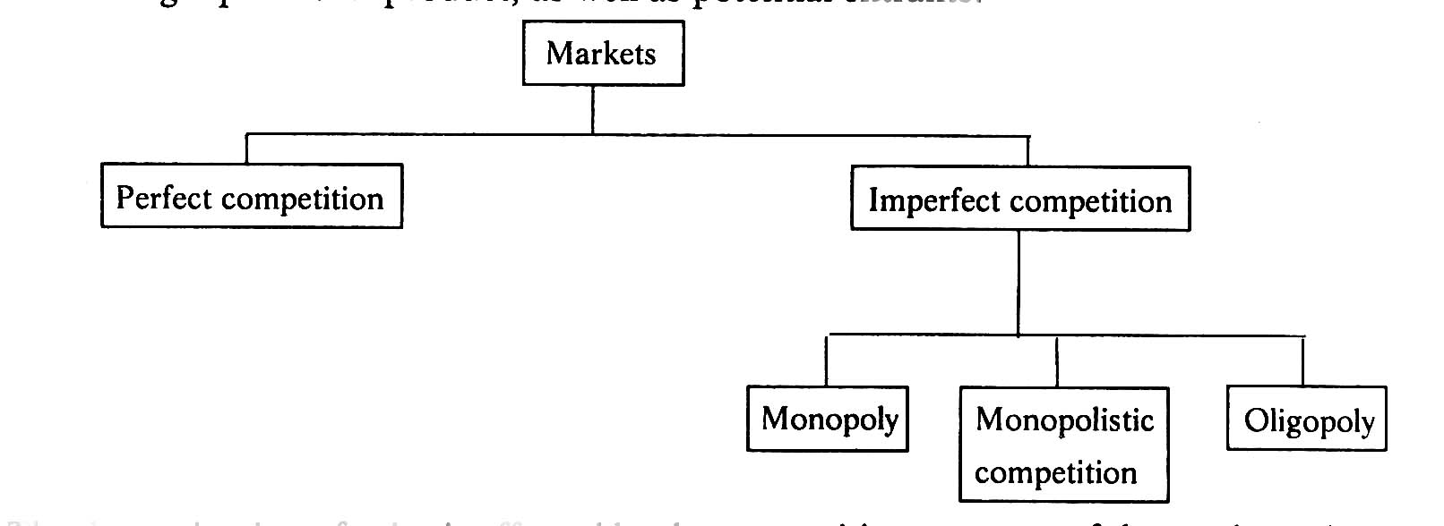

### Perfect Competition

Perfect competition refers to a market structure where competition among the sellers and buyers prevails in its most perfect form. In a perfectly competitive market, a single market price prevails for the commodity, which is determined by the forces of total demand and total supply in the market.

### Characteristics of Perfect Competition

The following features characterize a perfectly competitive market:

1. **A large number of buyers and sellers:** The number of buyers and sellers is large and the share of each one of them in the market is so small that none has any influence on the market price.
2. **Homogeneous product:** The product of each seller is totally undifferentiated from those of the others.
3. **Free entry and exit**: Any buyer and seller is free to enter or leave the market of the commodity.
4. **Perfect knowledge**: All buyers and sellers have perfect knowledge about the market for the commodity.
5. **Indifference:** No buyer has a preference to buy from a particular seller and no seller to sell to a particular buyer.
6. **Non-existence of transport costs**: Perfectly competitive market also assumes the non-existence of transport costs.
7. **Perfect mobility of factors of production**: Factors of production must be in a position to move freely into or out of industry and from one firm to the other.

Under such a market no single buyer or seller plays a significant role in price determination. One the other hand all of them jointly determine the price. The price is determined in the industry, which is composed of all the buyers and seller for the commodity. The demand curve facing the industry is the sum of all consumers’ demands at various prices. The industry supply curve is the sum of all sellers’ supplies at various prices.

### Pure competition and perfect competition

The term perfect competition is used in a wider sense. Pure competition has only limited assumptions. When the assumptions, that large number of buyers and sellers, homogeneous products, free entry and exit are satisfied, there exists pure competition. Competition becomes perfect only when all the assumptions (features) are satisfied. Generally pure competition can be seen in agricultural products.

**Equilibrium of a firm and industry under perfect competition**

Equilibrium is a position where the firm has no incentive either to expand or contrast its output. The firm is said to be in equilibrium when it earn maximum profit. There are two conditions for attaining equilibrium by a firm. They are:

Marginal cost is an additional cost incurred by a firm for producing and additional unit of output. Marginal revenue is the additional revenue accrued to a firm when it sells one additional unit of output. A firm increases its output so long as its marginal cost becomes equal to marginal revenue. When marginal cost is more than marginal revenue, the firm reduces output as its costs exceed the revenue. It is only at the point where marginal cost is equal to marginal revenue, and then the firm attains equilibrium. Secondly, the marginal cost curve must cut the marginal revenue curve from below. If marginal cost curve cuts the marginal revenue curve from above, the firm is having the scope to increase its output as the marginal cost curve slopes downwards. It is only with the upward sloping marginal cost curve, there the firm attains equilibrium. The reason is that the marginal cost curve when rising cuts the marginal revenue curve from below.

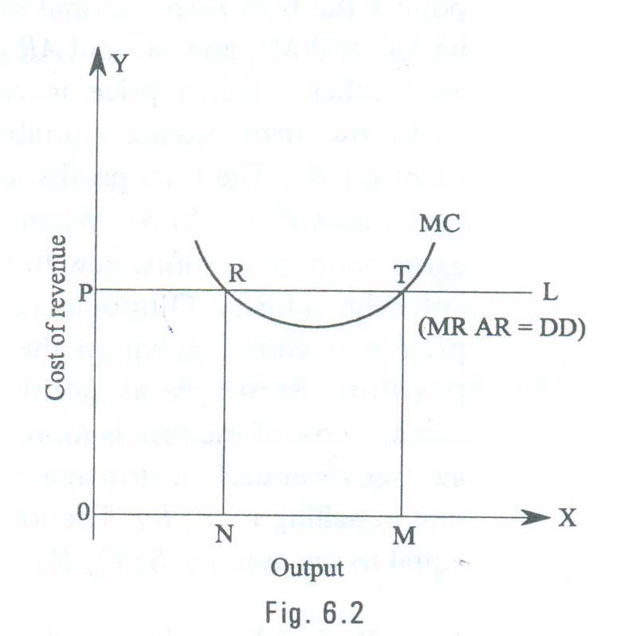

The equilibrium of a perfectly competitive firm may be explained with the help of the fig. 6.2.

In the given fig. PL and MC represent the Price line and Marginal cost curve. PL also represents Marginal revenue, Average revenue and demand. As Marginal revenue, Average revenue and demand are the same in perfect competition, all are equal to the price line. Marginal cost curve is U- shaped curve cutting MR curve at R and T. At point R marginal cost becomes equal to marginal revenue. But MC curve cuts the MR curve fro above. So this is not the equilibrium position. The downward sloping marginal cost curve indicates that the firm can reduce its cost of production by increasing output. As the firm expands its output, it will reach equilibrium at point T. At this point, on price line PL; the two conditions of equilibrium are satisfied. Here the marginal cost and marginal revenue of the firm remain equal. The firm is producing maximum output and is in equilibrium at this stage. If the firm continues its output beyond this stage, its marginal cost exceeds marginal revenue resulting in losses. As the firm has no idea of expanding or contracting its size of out, the firm is said to be in equilibrium at point T.

# Monopoly

The word monopoly is made up of two syllables, Mono and poly. Mono means single while poly implies selling. Thus monopoly is a form of market organization in which there is only one seller of the commodity. There are no close substitutes for the commodity sold by the seller. Pure monopoly is a market situation in which a single firm sells a product for which there is no good substitute.

### Features of monopoly

The following are the features of monopoly.

1. **Single person or a firm:** A single person or a firm controls the total supply of the commodity. There will be no competition for monopoly firm. The monopolist firm is the only firm in the whole industry.
2. **No close substitute:** The goods sold by the monopolist shall not have closely competition substitutes. Even if price of monopoly product increase people will not go in far substitute. For example: If the price of electric bulb increase slightly, consumer will not go in for kerosene lamp.
3. **Large number of Buyers:** Under monopoly, there may be a large number of buyers in the market who compete among themselves.
4. **Price Maker:** Since the monopolist controls the whole supply of a commodity, he is a price-maker, and then he can alter the price.
5. **Supply and Price:** The monopolist can fix either the supply or the price. He cannot fix both. If he charges a very high price, he can sell a small amount. If he wants to sell more, he has to charge a low price. He cannot sell as much as he wishes for any price he pleases.
6. **Downward Sloping Demand Curve:** The demand curve (average revenue curve) of monopolist slopes downward from left to right. It means that he can sell more only by lowering price.

### Types of Monopoly

Monopoly may be classified into various types. The different types of monopolies are explained below:

1. **Legal Monopoly:** If monopoly arises on account of legal support or as a matter of legal privilege, it is called Legal Monopoly. Ex. Patent rights, special brands, trade means, copyright etc.
2. **Voluntary Monopoly:** To get the advantages of monopoly some private firms come together voluntarily to control the supply of a commodity. These are called voluntary monopolies. Generally, these monopolies arise with industrial combinations. These voluntary monopolies are of three kinds (a) cartel (b) trust (c) holding company. It may be called artificial monopoly.
3. **Government Monopoly:** Sometimes the government will take the responsibility of supplying a commodity and avoid private interference. Ex. Water, electricity. These monopolies, created to satisfy social wants, are formed on social considerations. These are also called Social Monopolies.
4. **Private Monopoly:** If the total supply of a good is produced by a single private person or firm, it is called private monopoly. Hindustan Lever Ltd. Is having the monopoly power to produce Lux Soap.
5. **Limited Monopoly:** if the monopolist is having limited power in fixing the price of his product, it is called as ‘Limited Monopoly’. It may be due to the fear of distant substitutes or government intervention or the entry of rivals firms.
6. **Unlimited Monopoly:** If the monopolist is having unlimited power in fixing the price of his good or service, it is called unlimited monopoly. Ex. A doctor in a village.
7. **Single Price Monopoly:** When the monopolist charges same price for all units of his product, it is called single price monopoly. Ex. Tata Company charges the same price to all the Tata Indiaca Cars of the same model.
8. **Discriminating Monopoly:** When a Monopolist charges different prices to different consumers for the same product, it is called discriminating monopoly. A doctor may take Rs.20 from a rich man and only Rs.2 from a poor man for the same treatment.
9. **Natural Monopoly:** Sometimes monopoly may arise due to scarcity of natural resources. Nature provides raw materials only in some places. The owner of the place will become monopolist. For Ex. Diamond mine in South Africa.

### Pricing under Monopoly

Monopoly refers to a market situation where there is only one seller. He has complete control over the supply of a commodity. He is therefore in a position to fix any price. Under monopoly there is no distinction between a firm and an industry. This is because the entire industry consists of a single firm.

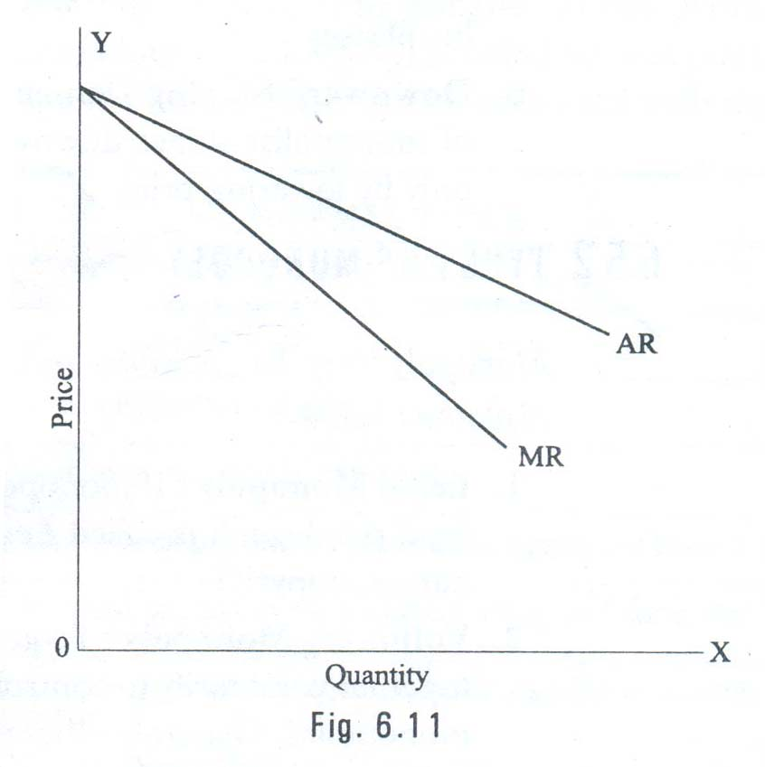

Being the sole producer, the monopolist has complete control over the supply of the commodity. He has also the power to influence the market price. He can raise the price by reducing his output and lower the price by increasing his output. Thus he is a price-maker. He can fix the price to his maximum advantages. But he cannot fix both the supply and the price, simultaneously. He can do one thing at a time. If the fixes the price, his output will be determined by the market demand for his commodity. On the other hand, if he fixes the output to be sold, its market will determine the price for the commodity. Thus his decision to fix either the price or the output is determined by the market demand.

The market demand curve of the monopolist (the average revenue curve) is downward sloping. Its corresponding marginal revenue curve is also downward sloping. But the marginal revenue curve lies below the average revenue curve as shown in the figure. The monopolist faces the down-sloping demand curve because to sell more output, he must reduce the price of his product. The firm’s demand curve and industry’s demand curve are one and the same. The average cost and marginal cost curve are U shaped curve. Marginal cost falls and rises steeply when compared to average cost.

**Price output determination (Equilibrium Point)**

The monopolistic firm attains equilibrium when its marginal cost becomes equal to the marginal revenue. The monopolist always desires to make maximum profits. He makes maximum profits when MC=MR. He does not increasing his output if his revenue exceeds his costs. But when the costs exceed the revenue, the monopolist firm incur loses. Hence the monopolist curtails his production. He produces up to that point where additional cost is equal to the additional revenue (MR=MC). Thus point is called equilibrium point. The price output determination under monopoly may be explained with the help of a diagram.

In the diagram 6.12 the quantity supplied or demanded is shown along X-axis. The cost or revenue is shown along Y-axis. AC and MC are the average cost and marginal cost curves respectively. AR and MR curves slope downwards from left to right. AC and MC and U shaped curves. The monopolistic firm attains equilibrium when its marginal cost is equal to marginal revenue (MC=MR). Under monopoly, the MC curve may cut the MR curve from below or from a side. In the diagram, the above condition is satisfied at point E. At point E, MC=MR. The firm is in equilibrium. The equilibrium output is OM.

The above diagram (Average revenue) = MQ or OP

Average cost = MR

Profit per unit = Average Revenue-Average cost=MQ-MR=QR

Total Profit = QRXSR=PQRS

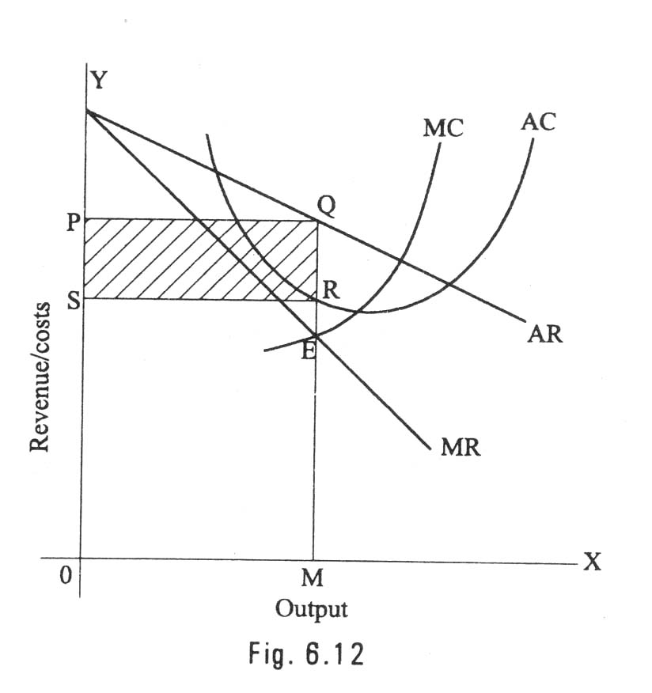

The area PQRS resents the maximum profit earned by the monopoly firm.

But it is not always possible for a monopolist to earn super-normal profits. If the demand and cost situations are not favorable, the monopolist may realize short run losses.

Through the monopolist is a price marker, due to weak demand and high costs; he suffers a loss equal to PABC.

If AR > AC -> Abnormal or super normal profits.

If AR = AC -> Normal Profit

If AR < AC -> Loss

In the long run the firm has time to adjust his plant size or to use existing plant so as to maximize profits.

### Monopolistic competition

Perfect competition and pure monopoly are rate phenomena in the real world. Instead, almost every market seems to exhibit characteristics of both perfect competition and monopoly. Hence in the real world it is the state of imperfect competition lying between these two extreme limits that work. Edward. H. Chamberlain developed the theory of monopolistic competition, which presents a more realistic picture of the actual market structure and the nature of competition.

### Characteristics of Monopolistic Competition

The important characteristics of monopolistic competition are:

1. **Existence of Many firms:** Industry consists of a large number of sellers, each one of whom does not feel dependent upon others. Every firm acts independently without bothering about the reactions of its rivals. The size is so large that an individual firm has only a relatively small part in the total market, so that each firm has very limited control over the price of the product. As the number is relatively large it is difficult for these firms to determine its price- output policies without considering the possible reactions of the rival forms. A monopolistically competitive firm follows an independent price policy.
2. **Product Differentiation:** Product differentiation means that products are different in some ways, but not altogether so. The products are not identical but the same time they will not be entirely different from each other. IT really means that there are various monopolist firms competing with each other. An example of monopolistic competition and product differentiation is the toothpaste produced by various firms. The product of each firm is different from that of its rivals in one or more respects. Different toothpastes like Colgate, Close-up, Forehans, Cibaca, etc., provide an example of monopolistic competition. These products are relatively close substitute for each other but not perfect substitutes. Consumers have definite preferences for the particular verities or brands of products offered for sale by various sellers. Advertisement, packing, trademarks, brand names etc. help differentiation of products even if they are physically identical.
3. **Large Number of Buyers:** There are large number buyers in the market. But the buyers have their own brand preferences. So the sellers are able to exercise a certain degree of monopoly over them. Each seller has to plan various incentive schemes to retain the customers who patronize his products.
4. **Free Entry and Exist of Firms:** As in the perfect competition, in the monopolistic competition too, there is freedom of entry and exit. That is, there is no barrier as found under monopoly.
5. **Selling costs:** Since the products are close substitute much effort is needed to retain the existing consumers and to create new demand. So each firm has to spend a lot on selling cost, which includes cost on advertising and other sale promotion activities.
6. **Imperfect Knowledge:** Imperfect knowledge about the product leads to monopolistic competition. If the buyers are fully aware of the quality of the product they cannot be influenced much by advertisement or other sales promotion techniques. But in the business world we can see that thought the quality of certain products is the same, effective advertisement and sales promotion techniques make certain brands monopolistic. For examples, effective dealer service backed by advertisement-helped popularization of some brands through the quality of almost all the cement available in the market remains the same.
7. **The Group:** Under perfect competition the term industry refers to all collection of firms producing a homogenous product. But under monopolistic competition the products of various firms are not identical through they are close substitutes. Prof. Chamberlin called the collection of firms producing close substitute products as a group.

#### Oligopoly

The term oligopoly is derived from two Greek words, oligos meaning a few, and pollen meaning to sell. Oligopoly is the form of imperfect competition where there are a few firms in the market, producing either a homogeneous product or producing products, which are close but not perfect substitute of each other.

### Characteristics of Oligopoly

The main features of oligopoly are:

1. **Few Firms:** There are only a few firms in the industry. Each firm contributes a sizeable share of the total market. Any decision taken by one firm influence the actions of other firms in the industry. The various firms in the industry compete with each other.
2. **Interdependence:** As there are only very few firms, any steps taken by one firm to increase sales, by reducing price or by changing product design or by increasing advertisement expenditure will naturally affect the sales of other firms in the industry. An immediate retaliatory action can be anticipated from the other firms in the industry every time when one firm takes such a decision. He has to take this into account when he takes decisions. So the decisions of all the firms in the industry are interdependent.
3. **Indeterminate Demand Curve:** The interdependence of the firms makes their demand curve indeterminate. When one firm reduces price other firms also will make a cut in their prices. So he firm cannot be certain about the demand for its product. Thus the demand curve facing an oligopolistic firm loses its definiteness and thus is indeterminate as it constantly changes due to the reactions of the rival firms.
4. **Advertising and selling costs:** Advertising plays a greater role in the oligopoly market when compared to other market systems. According to Prof. William J. Banumol “it is only oligopoly that advertising comes fully into its own”. A huge expenditure on advertising and sales promotion techniques is needed both to retain the present market share and to increase it. So Banumol concludes “under oligopoly, advertising can become a life-and-death matter where a firm which fails to keep up with the advertising budget of its competitors may find its customers drifting off to rival products.”
5. **Price Rigidity:** In the oligopoly market price remain rigid. If one firm reduced price it is with the intention of attracting the customers of other firms in the industry. In order to retain their consumers they will also reduce price. Thus the pricing decision of one firm results in a loss to all the firms in the industry. If one firm increases price. Other firms will remain silent there by allowing that firm to lost its customers. Hence, no firm will be ready to change the prevailing price. It causes price rigidity in the oligopoly market.

# Other Market Structures

#### Duopoly

Duopoly refers to a market situation in which there are only two sellers. As there are only two sellers any decision taken by one seller will have reaction from the other Eg. Coca-Cola and Pepsi. Usually these two sellers may agree to co-operate each other and share the market equally between them, So that they can avoid harmful competition.

The duopoly price, in the long run, may be a monopoly price or competitive price, or it may settle at any level between the monopoly price and competitive price. In the short period, duopoly price may even fall below the level competitive price with the both the firms earning less than even the normal price.

##### Monopsony

Mrs. Joan Robinson was the first writer to use the term monopsony to refer to market, which there is a single buyer. Monoposony is a single buyer or a purchasing agency, which buys the show, or nearly whole of a commodity or service produced. It may be created when all consumers of a commodity are organized together and/or when only one consumer requires that commodity which no one else requires.

##### Bilateral Monopoly

A bilateral monopoly is a market situation in which a single seller (Monopoly) faces a single buyer (Monoposony). It is a market of monopoly-monoposy.

##### Oligopsony

Oligopsony is a market situation in which there will be a few buyers and many sellers. As the sellers are more and buyers are few, the price of product will be comparatively low but not as low as under monopoly.

# Pricing Methods

The micro – economic principle of profit maximization suggests pricing by the marginal analysis. That is by equating MR to MC. However the pricing methods followed by the firms in practice around the world rarely follow this procedure. This is for two reasons; uncertainty with regard to demand and cost function and the deviation from the objective of short run profit maximization.

It was seen that there is no unique theory of firm behavior. While profit certainly on important variable for which every firm cares. Maximization of short – run profit is not a popular objective of a firm today. At the most firms seek maximum profit in the long run. If so the problem is dynamic and its solution requires accurate knowledge of demand and cost conditions over time. Which is impossible to come by?

In view of these problems economic prices are a rare phenomenon. Instead, firms set prices for their products through several alternative means. The important pricing methods followed in practice are shown in the chart.

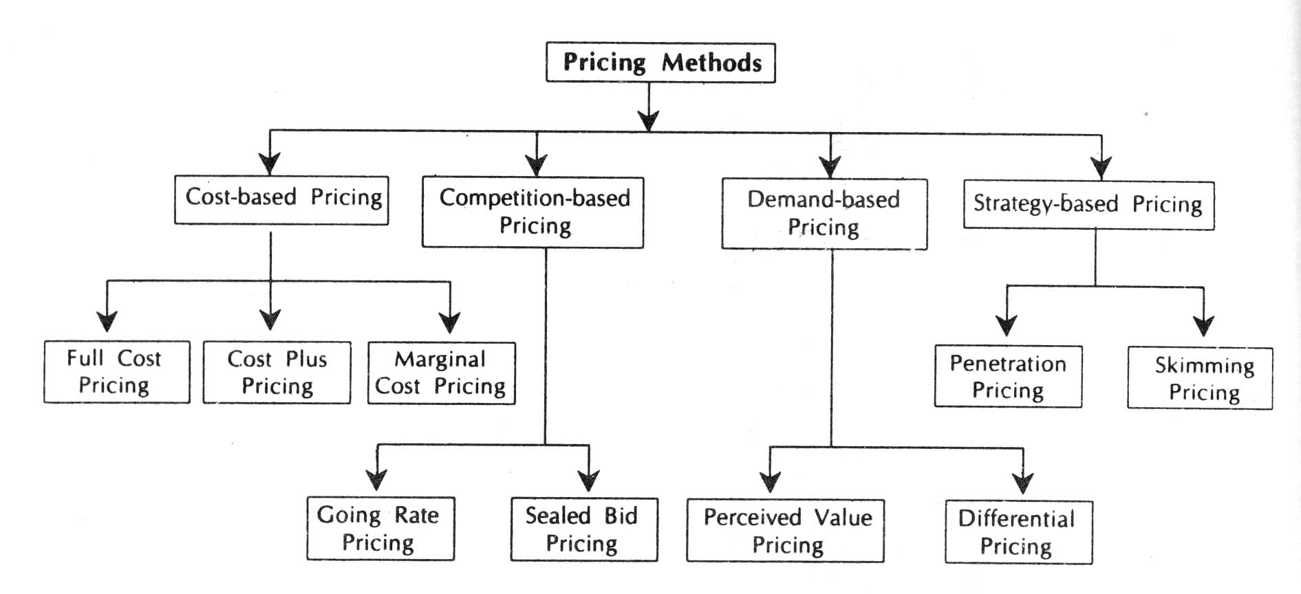

**Cost Based Pricing**

There are three versions of the cost – based pricing. Full – cost or break even pricing, cost plus pricing and the marginal cost pricing. Under the first version, price just equals the average (total) cost. In the second version, some mark-up is added to the average cost in arriving at the price. In the last version, price is set equal to the marginal cost. While all these methods appear to be easy and straight forward, they are in fact associated with a number of difficulties. Even through difficulties are there, the cost- oriented pricing is quite popular today.

The cost – based pricing has several strengths as well as limitations. The advantages are its simplicity, acceptability and consistency with the target rate of return on investment and the price stability in general. The limitations are difficulties in getting accurate estimates of cost (particularly of the future cost rather than the historic cost) Volatile nature of the variable cost and its ignoring of the demand side of the market etc.

**Competition based pricing**

Some commodities are priced according to the competition in their markets. Thus we have the going rate method of price and the sealed bid pricing technique. Under the former a firm prices its new product according to the prevailing prices of comparable products in the market. If the product is new in the country, then its import cost – inclusive of the costs of certificates, insurance, and freight and customs duty, is used as the basis for pricing, Incidentally, the price is not necessarily equal to the import cost, but to the firm is either new in the country, or is a close substitute or complimentary to some other products, the prices of hitherto existing bands or / and of the related goods are taken in to a account while deciding its price. Thus, when television was first manufactures in India, its import cost must have been a guiding force in its price determination. Similarly, when

maruti car was first manufactured in India, it must have taken into account the prices of existing cars, price of petrol, price of car accessories, etc. Needless to say, the going rate price could be below or above the average cost and it could even be an economic price.

The sealed bid pricing method is quite popular in the case of construction activities and in the disposition of used produces. In this method the prospective seller (buyers) are asked to quote their prices through a sealed cover, all the offers are opened at a preannounce time in the presence of all the competitors, and the one who quoted the least is awarded the contract (purchase / sale deed). As it sound, this method is totally competition based and if the competitors unit by any change, the buyers (seller) may have to pay (receive) an exorbitantly high (too low) price, thus there is a great degree of risk attached to this method of pricing.

**Demand Based Pricing**

The demand – based pricing and strategy – based pricing are quite related. The seller knows rather well that the demand for its product is a decreasing function of the price its sets for product. Thus if seller wishes to sell more he must reduce the price of his product, and if he wants a good price for his product, he could sell only a limited quantity of his good. Demand oriented pricing rules imply establishment of prices in accordance with consumer preference and perceptions and the intensity of demand.

Two general types demand oriented pricing rules can be identified.

* 1. Perceived value pricing and
  2. Differential pricing

Perceived value pricing considers the buyer’s perception of the value of the product ad the basis of pricing. Here the pricing rule is that the firm must develop procedures for measuring the relative value of the product as perceived by consumers. Differential pricing is nothing but price discrimination. In involves selling a product or service for different prices in different market segments. Price differentiation depends on geographical location of the consumers, type of consumer, purchasing quantity, season, time of the service etc. E.g. Telephone charges, APSRTC charges.

**Strategy based pricing (new product pricing)**

A firm which products a new product, if it is also new to industry, can earn very good profits it if handles marketing carefully, because of the uniqueness of the product. The price fixed for the new product must keep the competitors away. Earn good profits for the firm over the life of the product and must help to get the product accepted. The company can select either skimming pricing or penetration pricing.

While there are some firms, which follow the strategy of price penetration, there are some others who opt for price – skimming. Under the former, firms sell their new product at a low price in the beginning in order to catch the attention of consumers, once the product image and credibility is established, the seller slowly starts jacking up the price to reap good profits in future. Under this strategy, a firm might well sell its product below the cost of production and thus runs into losses to start with but eventually it recovers all its losses and even makes good overall profits. The Rin washing soap perhaps falls into this category. This soap was sold at a rather low price in the beginning and the firm even distributed free samples. Today, it is quite an expensive brand and yet it is selling very well. Under the price – skimming strategy, the new product is priced high in the beginning, and its price is reduced gradually as it faces a dearth of buyers such a strategy may be beneficial for products, which are fancy, but of poor quality and / or of insignificant use over a period of time.

A prudent producer follows a good mix of the various pricing methods rather than adapting any once of them. This is because no method is perfect and every method has certain good features further a firm might adopt one method at one time and another method at some other accession.